**Pico CTF Challenge**

**Intro To Burp**

**(Pathway)**

**Challenge 3 : Intro To Burp**

**Category :** Web Exploitation

**Difficulty :**  Easy

**Description :** Additional details available after launching the Instance

Analyse the page and setup Burpsuite

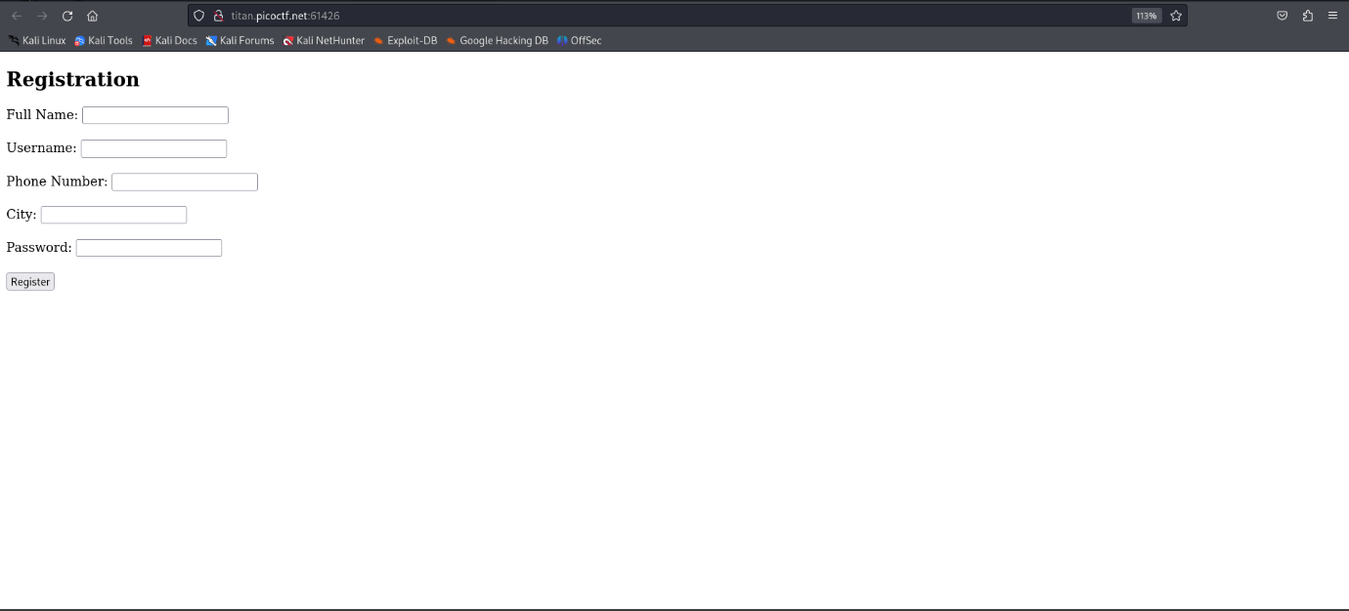

Here 5 columns are available and let’s input something and try intercepting using burp.

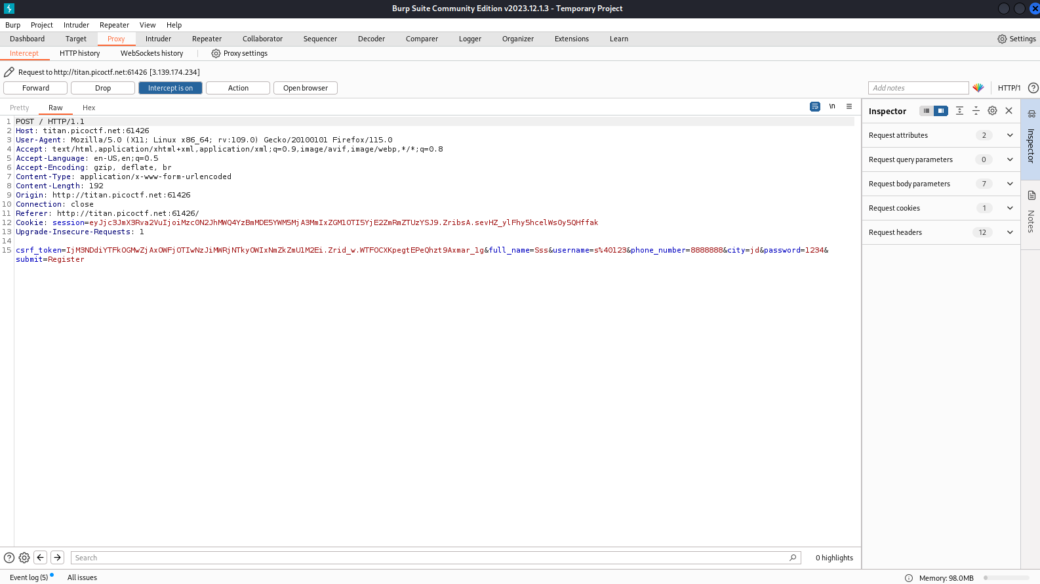

This is the intercepted result after inputting on the webpage. Continue clicking forward button and we will get 2FA page.

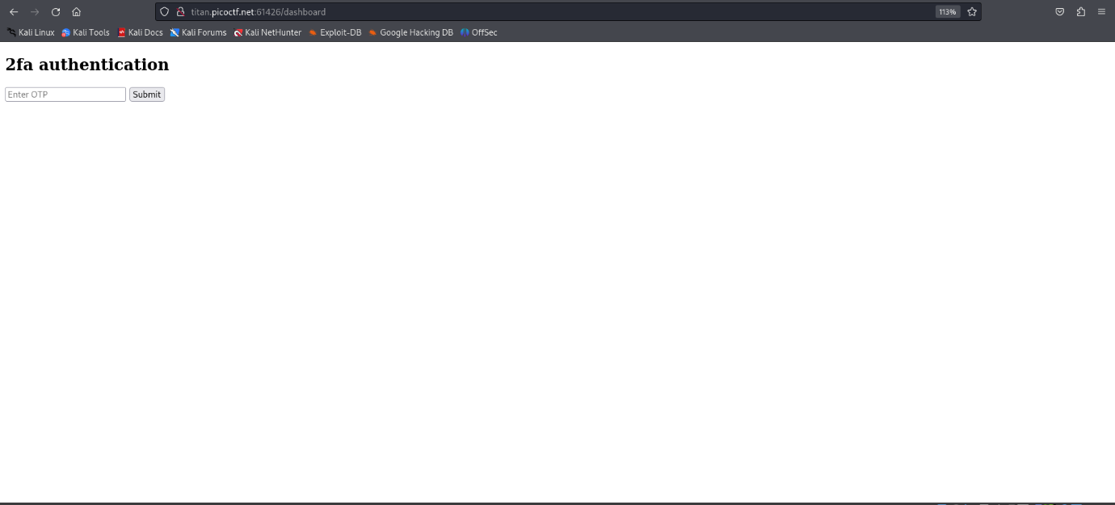

Just input something and try intercepting

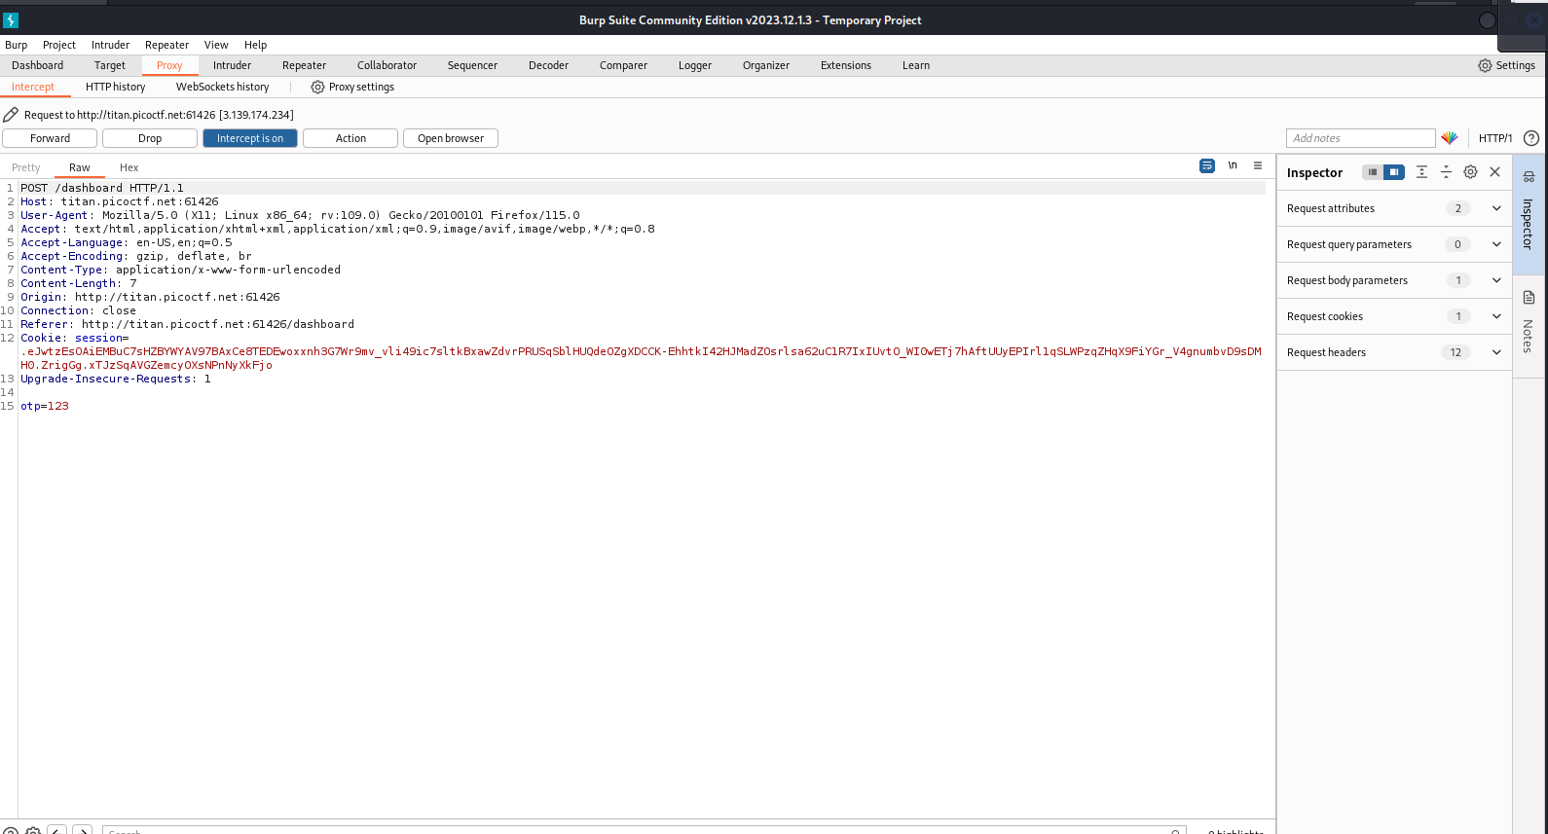This is the output, here we can see the otp I entered is 123, just delete that part and press forward, like bypassing the request.

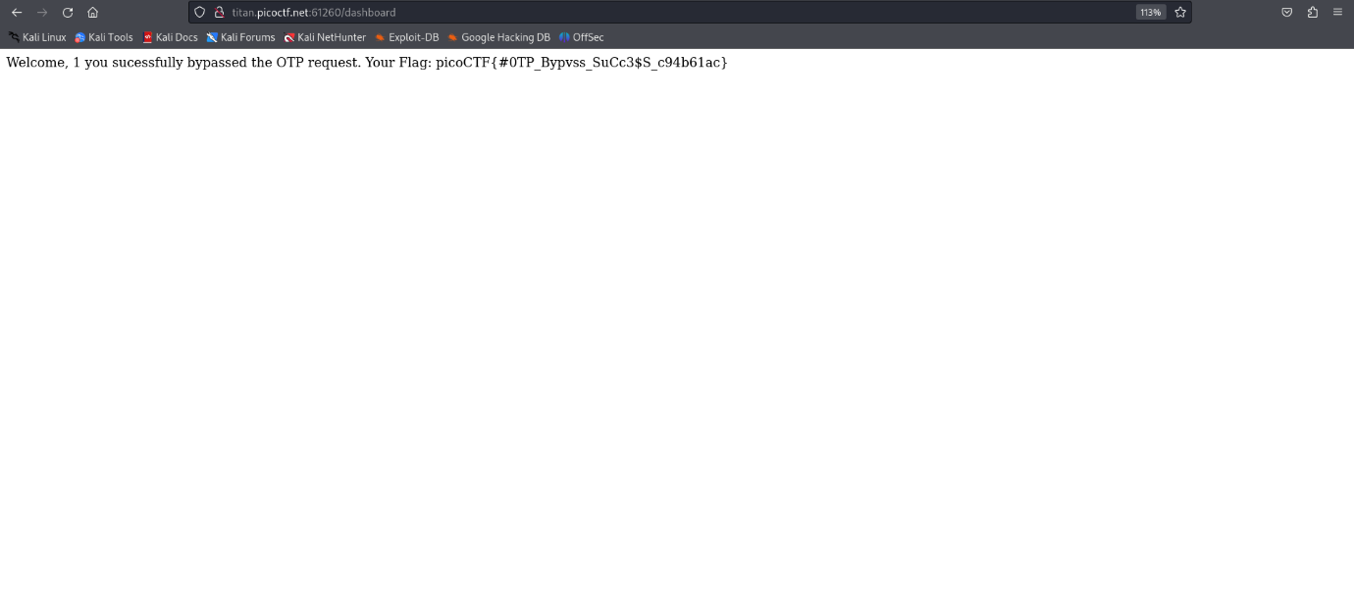

Here is the flag